Lab Assignment #2
Aircraft Tail Section Stress Analysis using Axial Finite Elements

EAE 133 - Finite Element Methods in Structures
Professor N. Sarigul-Klijn
TA: Noah Derita

Aurian Malhotra
920005606
Section A04, 10/9/2025

Introduction
The purpose of this lab was to determine the nodal displacements and axial stresses in each member of an aircraft tail section modeled as a truss under given loading conditions. Using the geometry shown in Figure 1, trigonometric relationships were applied to determine the x and y components of each load for the model’s coordinate system. Each node was then assigned a position vector relative to point 5 at [0 0 0]. These calculated values were imported into Patran to construct the geometry, apply boundary and loading conditions, generate a mesh, and perform a linear static analysis. The results from this analysis were used to evaluate the displacement and stress response of each truss member.

Figure 1: 2D Truss Structure Model of an Aircraft Tail Section
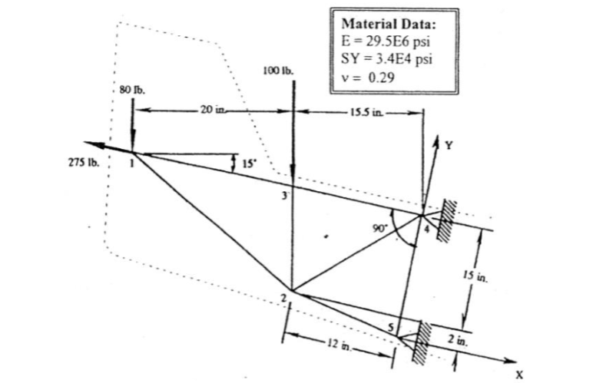

Procedure
Using the given angles and distances in Figure 1 trigonometric calculations were made to solve for the x and y components of the loads for the given coordinate system. Given 80 lbf and a 15° angle this load can be split into x = 80sin(15°) = 20.71 lbf and y = 80cos(15°) = -77.27 lbf. Similarly the 100 lbf load can be split into x and y components of 25.88 lbf and -96.59 lbf respectively, and the 275 lbf in the negative x direction will remain the same for Patran.

Likewise, after performing trigonometry equations for the loads, the same has to be done to solve for the coordinates of each point. Placing point 5 at the origin [0 0 0], the rest of the points are calculated relatively. The calculations for 1, 2, and 3 are below in Figure 2 as 4 is obviously [0 17 0]. Following the calculations is Table 1 showing all the position vector quantities being inputted to Patran to set the points of the structure.

Figure 2: Calculations for Position Vectors for Points 1-5

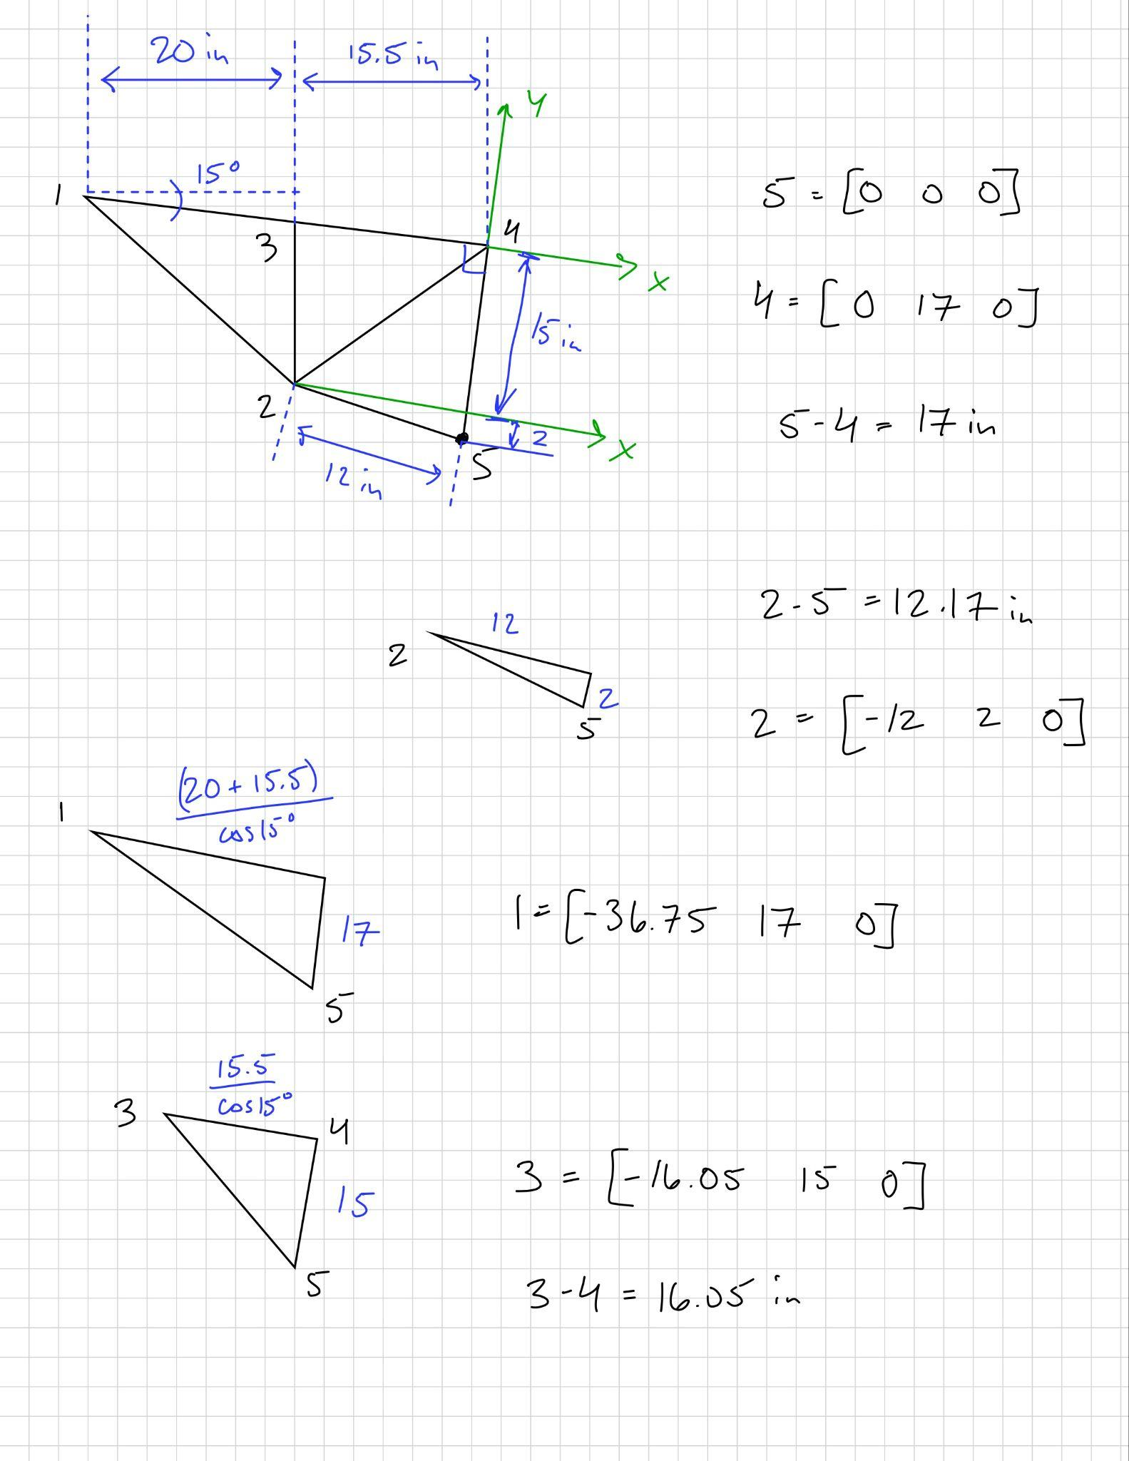

Table 1: Position Vector Quantities

Node | 1 | 2 | 3 | 4 | 5
Coordinates | [-36.75 17 0] | [-12 2 0] | [-16.05 17 0] | [0 17 0] | [0 0 0]

After determining the load components and calculating the position vectors for each node, all values were entered into Patran to begin model construction. Using the coordinates from Table 1, the geometry was created by defining five nodes and connecting them with linear curves in the configuration shown in Figure 1. Each curve was assigned material properties following a linear elastic constitutive model, with an elastic modulus of 29.5E+06 psi and a uniform cross-sectional area of 1 in² for every truss member.

Boundary and loading conditions were then applied. Nodes 4 and 5 were constrained with pin supports, while nodes 1 and 3 received the external loads. At node 1, loads of -275 lbf and +20.71 lbf were applied in the x-direction and -77.27 lbf in the y-direction. At node 3, loads of +25.88 lbf and -96.59 lbf were applied in the x and y directions respectively. After defining these conditions, mesh seeds were assigned to each element, and a uniform mesh was generated for the entire structure.

A linear static analysis was then performed using MSC NASTRAN. The resulting .f06 and .xdb output files were reviewed in Patran to obtain the nodal displacements and axial stresses for each member (Tables 2 and 3). Fringe and deformation plots were produced to visualize the stress distribution and scaled displacements, shown in Figure 3.

Results
The deformation plot shows the expected deflection pattern driven by loads at nodes 1 and 3 and reaction at the supports (nodes 4 and 5). The stress plot shows which members are in tension as the bracing members compress to balance the structure.

Figure 3: Undeflected vs. Deflected Tail Structure with Axial Stress

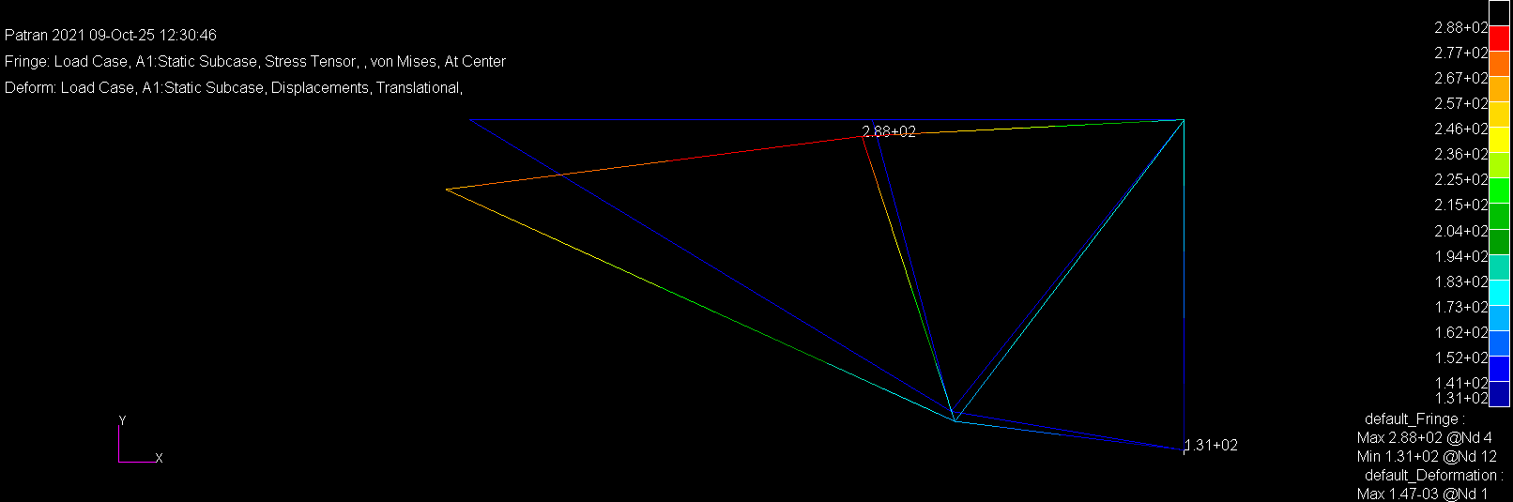

Table 2: Axial Stresses in Truss Members

Truss Members | (1-2) | (2-3) | (1-3) | (3-4) | (2-4) | (4-5) | (2-5)
Axial Stress (psi) | -1.490830E+02 | -1.000488E+02 | 3.817855E+02 | 3.819848E+02 | 1.675331E+02 | 0 | -2.617939E+02

Table 2 summarizes the axial stress results (psi) for each truss member, where positive values indicate tension and negative values indicate compression. The highest tension occurs in members (1-3) and (3-4) while the most compressed in (2-5).

Table 3: Nodal Displacements

Node |  | 1 | 2 | 3 | 4 | 5
Displacements (in) | X | -4.757226E-04 | 7.602907E-05 | -2.078256E-04 | 0 | 0
 | Y | -1.393103E-03 | -2.005288E-04 | -3.317504E-04 | 0 | 0

Table 3 lists the translational displacements (in inches) at each node, showing that the largest deflection occurs at node 1 in the negative y-direction, with minimal movement near the pinned supports (nodes 4 and 5), confirming correct boundary condition behavior.

The finite element linear elastic analysis of 1D axial truss elements produced the nodal displacements (in) and axial stresses (psi) summarized above. Node and element ID’s are consistent with Figure 1. Displacements are small relative to member lengths, consistent with the linear assumption, and the stress field follows the applied loads at nodes 1 and 3 toward the supports at nodes 4 and 5. Tension develops along the load path and compression in the complementary bracing members. Figure 3 overlays the deflected shape and axial stresses for a visual check of load flow.

Discussion/Conclusion
Because the truss was modeled using only axial elements, each member carried purely axial loads without bending. The direction and magnitude of stress in each bar reflected how the structure redistributed the applied forces from nodes 1 and 3 toward the pinned supports at nodes 4 and 5. Members directly connecting the loaded joints to the supports carried tension, while the diagonal bracing members experienced compression as they stabilized the frame. This pattern is clearly shown in the fringe plot, where the highest tensile stresses occurred along the main load paths, and compressive regions developed in the supporting braces.

The most significant tensile stress occurred in members (1-3) and (3-4) at approximately 382 psi, while the largest compression appeared in member (2-5) at -262 psi. All of these values are far below the yield strength of 3.4E+04 psi, producing a safety factor of ~89, which confirms the structure easily remained within elastic limits. The maximum nodal displacement, roughly 1.4E-03 inches at node 1 in the negative y-direction, was extremely small compared to the member lengths, validating the assumption of small deflections. Overall, the results align with expectations for a linear elastic truss under static loading: stresses follow the geometry and boundary conditions, the displacement field behaves realistically, and the finite-element model accurately represents how loads travel through the aircraft tail section.

